# ib logoPalm Harbor University High School International Baccalaureate Language Arts 2024-2025 School Year

**Summer Assignment**

**9th Grade Pre-IB English Instructors:**

E. Hodge & E. Peluso & J. Tharin

*We pressed a thought into the wayside, planted an impression along the verge.*

- from “Marginalia” by Billy Collins

Summer Assignment

You will need these works for class during the first few weeks of school, and I will be checking your annotations for a grade. On the first or second session of school, students should be prepared to demonstrate their knowledge of theses texts by writing either an essay or taking a quote-based test.

* ***How to Read Literature Like a Professor,*** Thomas C. Foster
  + HarperCollins Publishers, ISBN: 978-0-06-230167-3
* **Choice Text: Select ONE of the following books**
  + ***Ender’s Game****,* Orson Scott Card
    - Sensitive topics: violence
  + ***The Girl Who Circumnavigated Fairyland in a Ship of Her Own Making***, Catherynne M. Valente
    - Sensitive topics: violence
  + ***The Golden Compass***, Phillip Pullman
    - sensitive topics: violence
  + ***The Hobbit***, J.R. Tolkien
    - sensitive topics: violence
  + ***Ranger’s Apprentice Book One: The Ruins of Gorlan****,* John Flanagan
    - Sensitive topics: violence

## Engaging with Controversial Materials: Some of these books contain sensitive topics. Feel free to google trigger warnings for these books if you need to. The selection of texts is totally up to you. All studies in language and literature courses will provide the opportunity to engage with a broad range of texts, approaches, ideas, stimuli and interpretations that address topics of personal, local and global significance. These works may challenge learners intellectually, personally and culturally, and involve sensitive and mature topics. The courses studied may explicitly address sensitive topics through texts and issues discussed while inviting students to critically reflect on various perspectives offered. In general, approaching sensitive topics in studies in language and literature courses must be done through an intellectually critical lens avoiding gratuitous excess and/or superficial treatment and bearing in mind the IB’s commitment to international-mindedness and intercultural respect.

## Overview:

This looks like more work than it is. The novels are short and engaging. You may choose a poem you enjoy from the website provided. Your responses should only be a paragraph each. Over the summer you are expected to complete the following for a grade, the assignments are detailed below:

1. Read and annotate the following chapters from ***How to Read Literature Like a Professor*** 
   1. Chapter 1: Every Trip is a Quest (Except When It’s Not)
   2. Chapter 4: Now, Where Have I Seen Her Before?
   3. Chapter 5: When in Doubt, It’s from Shakespeare
   4. Chapter 6: . . . Or the Bible
   5. Chapter 7: Hanseldee and Greteldum
   6. Chapter 8: It’s Greek to Me
   7. Chapter 12: Is That a Symbol?
   8. Chapter 19: Geography Matters
   9. Chapter 25: It’s My Symbol and I’ll Cry If I Want To
2. Read and annotate ***choice text***
3. Complete 5 journal entries for ***choice text.***
4. Read and colormark **one poem** and complete 1 poetry journal entry.

## Annotating:

First with ***How to Read Literature Like a Professor***, and then with ***choice text*,** you will need to carefully read through and annotate by noting pithy quotations, important moments, and literary details. Annotating is a way of forcing yourself to read closely, pay attention to the words, process and remember the concepts, and hopefully engage with and enjoy the text.

See [this internet source](https://slowreads.wordpress.com/2008/04/18/how-to-mark-a-book/) for ideas on what to annotate. Some annotation every few pages should be considered a minimum.

Do the following:

* Mark things you like, puzzle you, disturb you, and resonate with you.
* Look up words you do not know and write the definitions in the margin.
* Mark any literary devices you are familiar with and any patterns of ideas or images.
* In *choice text* mark connections to *How to Read Literature Like a Professor*
* Jot notes and questions in the margin.
* Talk back to the text by giving your emotional or critical responses.
* Please don’t forget to enjoy the book.

## Writing Expectations

As this is a literature and composition course, you will be expected to use every assignment that involves writing to practice your best composition skills. For your journal entries, you will be typing your responses. Make sure to save a digital copy so that you can upload your assignment to your teacher for your first homework grade. Your paragraph responses will be graded on the following criteria:

## Stand-Alone Paragraph Evaluation Criteria:

1. The first sentence contains the **assertion** and key words from the question or assigned topic.
2. Paragraph contains two to four **explanatory** sentences.
3. Paragraph contains three to five sentences about specific **details** (things in **quotation** marks).
4. Details are colorful, interesting, and appropriate.
5. Paragraph ends with a good **concluding sentence** that refers to the assertion without repeating it.
6. Paragraph contains no run-ons or sentence fragments.
7. Paragraph is free of errors in agreement.
   1. Subject/verb—singular or plural
   2. Pronoun selection correct—singular or plural
   3. Pronoun selection correct—subject or object

**Journal Assignments:**

1. The first entry should be about you—nothing fancy, just an overview: your likes, dislikes, fears, hopes, ambitions, favorite books, study habits, work ethic, and goals. Be specific—specific is interesting. We will be sharing these in class, so don’t share anything you are not comfortable sharing.
2. Review Chapter 1 from ***How to Read Literature Like a Professor*** and list the 5 aspects of the Quest and apply them to ***choice text.*** Prove to me that Santiago is, in fact, on a quest and use specific details from the text to support your assertion.
3. Review Chapter 12 and 25 on symbolism from *How to Read Literature Like a Professor* and identify two symbols in ***choice text***and discuss what Foster calls “the secondary meaning” of your two symbols. Conclude this journal with an understanding of how these symbols contribute to theme. Theme is a statement about how the author treats the subject
4. Review Chapters 4, 5, 6, 7 & 8 from ***How to Read Literature Like a Professor*** and define intertextuality. Give three examples from ***choice text*** and discuss their significance.
5. Review Chapter 19 from ***How to Read Literature Like a Professor*** and discuss what the geography in ***choice text*** contributes to theme. Theme is a statement about how the author treats the subject.

## Poetry Assignment Requirements:

* Choose **one** poem that relates to you (your values, likes/dislikes, journey, fears, etc.) from the Poetry 180 website: [http://www.loc.gov/poetry/180/.](http://www.loc.gov/poetry/180/.%20) As you read the poem, use these questions to guide what you write about in your journal. Use specific details to support your answers.
  + What is the literal situation of the poem?
  + Who is the speaker?
  + What piece of life, private or public, is the poem concerned with? Be specific.
  + Where and when is this life being lived?
  + What kind of image patterns have you found? How do they affect meaning?
  + What is the tone? How do you know?
  + Where is the shift in tone? How does it affect meaning?
  + What is the major theme of the poem?
  + What is the significance of the title?
  + What is the poet’s purpose in writing it?

## Steps:

## Read my model colormarking and journal entry below. This will give you an idea of the types of things that I am looking for in your paragraph.

## Choose your poem from the website which you enjoy and which you feel compfroatble talking about in class, you are by no means required to analyze a poem that you’re uncomfortable with.

## Colormark the poem for literary devices (see below)

## Write a one paragraph journal entry after you’ve colormarked.

## In the title of your journal entry indicate which poem (the number) you are writing about, along with the title and poet. Example: #1 “Introduction to Poetry” Billy Collins

## Answer of respond to some of the questions provided above in paragraph form.

## Literary Terms:

We will be dealing with them for poetry, prose, and drama. If you are not familiar with the following, I suggest you look them up online and also try and find them in your summer readings (these are wonderful for annotating and for analyzing in poems). These terms would also be appropriate to use in your journal entries. The terms are as follows: **metaphor, simile, mood, setting, allusion, tone, point of view, foreshadowing, personification, irony, symbol, hyperbole, understatement, flashback, and imagery.**

**Example Colormarked Poem:**

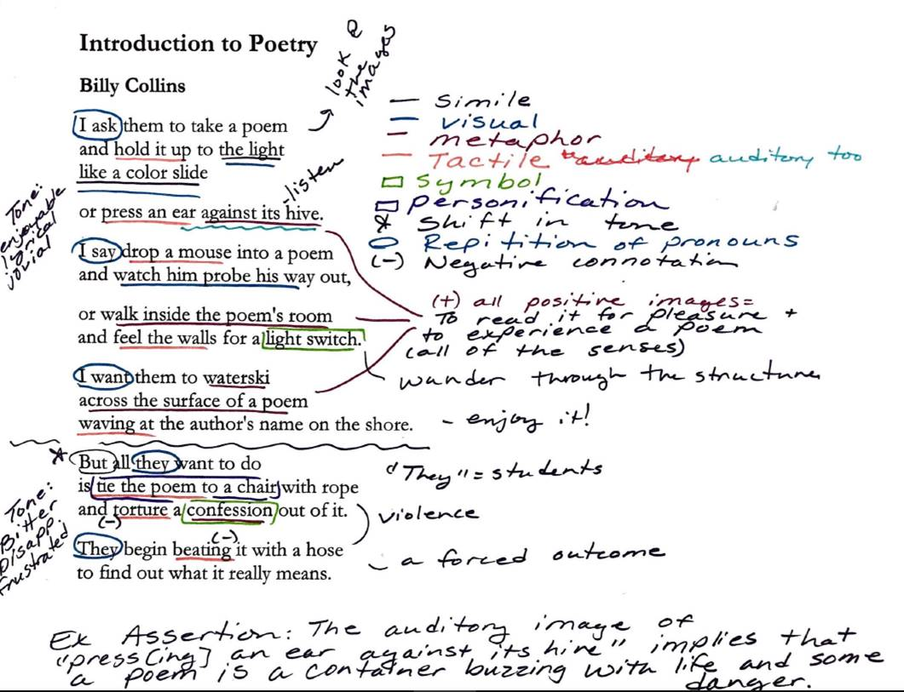

**Example Poetry Paragraph**:

Poetry Journal Entry: #1 “Introduction to Poetry” Billy Collins

Billy Collins’s “Introduction to Poetry” juxtaposes what a professor hopes to be the pleasurable experience of reading a poem with the seeming desires of his students to torture some deeper meaning out of it. The positive image pattern related to discovery connects many of the senses metaphorically to the pleasure of reading a poem. The visual image compares looking at an image in a “slide” to the discovery of beauty in a poem. The auditory image follows of “press[ing] an ear against its hive,” implying that a poem is a container buzzing with life, and some exciting danger. The tactile image of walking into “the poem’s room” and feeling around for a “light switch” reveals how sometimes reading a dark and confusing poem requires discovery, and that the pleasure in that moment is very much like sudden light in a dark room. The image of the “waterski” is both tactile, visual, and even gustatory with the taste of the spray of water, and it is perhaps the most pleasurable image in the poem calling upon experiences of vacations, summer, and fun. Furthermore, the image of “wav[ing] at the author’s name on the shore” reveals that the speaker is not concerned with who the poet is, and is furthered by the metonymy of the “the author’s name” as it separates the author even further from the experience of reading the poem. The shift in the poem occurs immediately after the “waterski” stanza, with the tone shifting from satisfying and enjoyable to bitter and disappointed. The torturous and mostly tactile image pattern characterizes the students, “they”, as active and purposeful, yet wholly inappropriate readers of poetry as they “tie it to a chair” and “beat” the meaning out of it. The theme, then, is that poems should not be read like a riddle, or like they have something to hide, but first for their pleasurable insight into the human condition—for their ability to bring a moment of joy into the English classroom and not a moment of pain for all involved (the poem, the professor, and the students).